Appendix

Activity Document IV

PROJECT ABSTRACT

TITLE: The Development of Gonystylus spp. (Ramin) Timber Monitoring System Using Radio Frequency Identification (RFID) in Peninsular Malaysia.

SUMMARY

Ramin (Gonystylus spp.) is one of the most important peat swamp forest tree species that is currently being utilized in Malaysia. There are widespread concerns about the rate at which the species is being exploited due to increasing demand for its timber by the industries, both locally and internationally. As a highly sought after species, there are also concerns that Ramin trees are under considerable threats from illegal logging and tax evasion that caused governments to lose forest revenues. Tree marking is one of the measures carried out by the Forestry Department Peninsular Malaysia (FDPM) to address these problems. It serves to regulate the harvestable number of trees and volume removed, as well as monitor non-compliance of forest operations in logging licensed areas, such as the felling of mother trees, protection trees, and trees located in buffer zones. This project will embark on the use of Radio Frequency Identification (RFID) technology instead of the manual timber tagging activities in the harvesting of peat swamp forest species, and in particular the Ramin species, with the aim of (i) development of a customized cost-effective Gonystylus spp. (Ramin) Timber Monitoring System Using Radio Frequency Identification (RFID) in Peninsular Malaysia; and (ii) development of an automated detection and notification mechanism for tracing non-compliances using gentry (gate) system in Peninsular Malaysia. This project is crucial in promoting sustainable utilization and conservation of Ramin in the production forests of Peninsular Malaysia.

EXECUTING/IMPLEMENTING AGENCY: Forestry Department Headquarters Peninsular Malaysia and the State Forestry Department of Pahang.

COLLABORATING AGENCY: Ministry of Natural Resources and Environment Malaysia.

DURATION: 8 months.

START DATE: 2008.

BUDGET AND PROPOSED SOURCES OF FINANCE:

(a) ITTO Contribution US$ 103,200

(b) Government Contribution (direct and in-kind) US$ 70,910

- Other Sources Contribution (specify) US$ -

Total US$ 174,110

This activity is submitted to ITTO for consideration under its Work Program activity “Ensuring international trade in CITES-listed timber species is consistent with their sustainable management and conservation,” with primary funding provided by the European Commission and additional support from the USA, Japan, New Zealand and Norway
PART I: CONTEXT

Origin/Background

The current major area of RFID applications includes data synchronization, transportation and distribution, and security and law enforcement. In view of this, it is envisaged that RFID technology can be integrated into the existing Forestry Department Peninsular Malaysia (FDFM) computer system. It also can be used as the basis of a new coding system for one of FDPM’s core business applications, such as its tree marking system in logging operation. These features will help to resolve many obstacles that FDPM are facing in controlling timber supply that are in compliance with the Malaysian Criteria and Indicator (MC&I) 2002 timber certification programme, chain-of-custody scheme and in monitoring revenue collection.

It is apparent that barcodes have been widely used for more than 30 years. However, the technology has reached its peak performance due to a nimber of limitations, such as easily being damage, its reader operations can be affected by moisture, and clear line of sight (no obstacles). It also could not be able to read every barcode if it moves at high speed, as well as, it does not have the ability to read/write, and information could not be added or written on a printed barcode. Hence, in this project, timber tagging system will be replaced with RFID chip (Figure 1). The chip will be implanted into logged trees and stumps in logging areas to determine the source of any specific logging licensed area, tree diameter, species, forest compartment and logging contractor among others. RFID chip in FDPM application can also be used as a permit for the transfer of logs from one area to another. Logs without identification will immediately alert the Department to take prompt and immediate action.

PART II: THE PROJECT

1.0 Ramin Timber RFID Monitoring System (RTRfid)

The system consist of several components, such as RFID chips, hand-held RFID readers (Figure 2), fixed RFID readers (portal or gentry–Figure 3) and tag programming stations as shown in the system schematic process flow (Figure 4). In the implementation of this project, trees to be logged will be surveyed to identify the tree species and diameter size, as well as to estimate the number of logs from each tree. All felled trees that are cut into logs, as well as the tree stumps will be implanted with RFID chips. The tag contains a transponder with a digital memory chip that is given a unique electronic identification code. The reader, an antenna packaged with a transceiver and decoder, emits a signal activating the RFID tag so that it can read into it. When an RFID chip passes through an electromagnetic zone, it detects the reader's activation signal. The reader decodes the data encoded in the tag's integrated circuit (silicon chip) and the data are passed to the host computer for processing. RFID hand-held device will transmit signal to detect the RFID tags in a given location. Once the signal detects the tags, it will store the information in the hand-held device and later all the daily information will be synchronized with the RTRfid system at the FDPM Headquarters and State Forestry Department offices. A portal (gentry) will be erected at the main road of the logging licensed area to read all the logs on the log truck. Information will then be sent to the Headquarters (Figure 5) to be monitored by FDPM officers.

Figure 1: RFID chip components

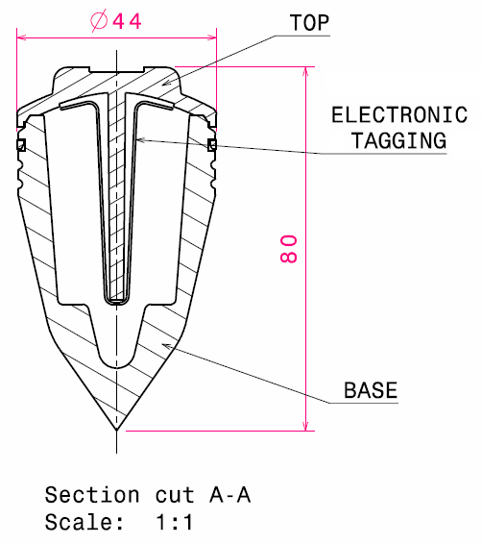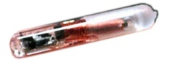
RFID Chip

Figure 2: Handheld data Logger and RFID reader

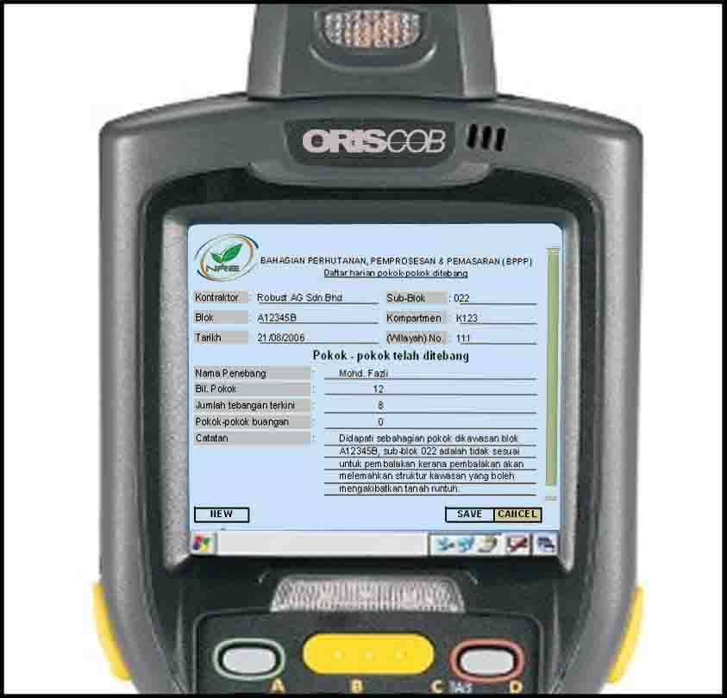

Figure 3: RFID Portal–Log Truck Data Capture
.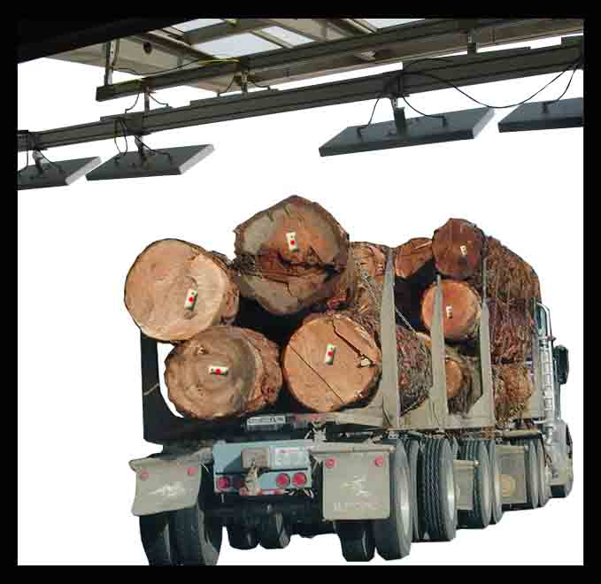
Figure 4: RTRfid System Schematic Process Flow
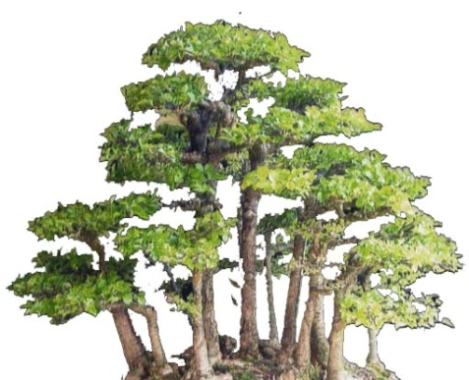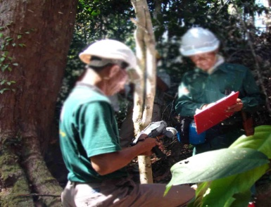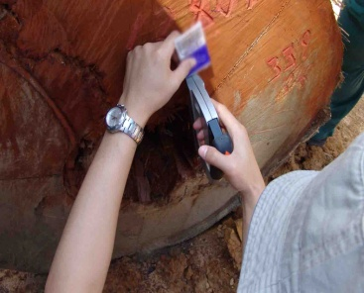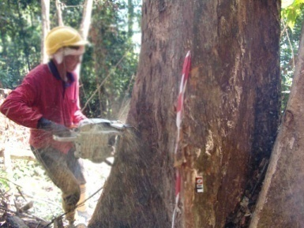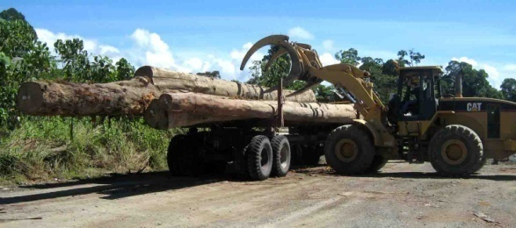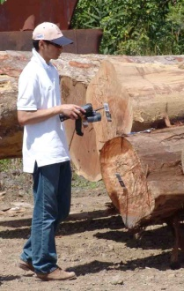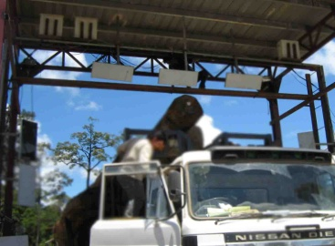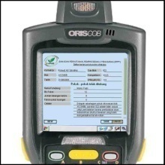
Sawmill
1. RFID Chip
4. Data re-capture
3. Felling
5. RFID Chip (Logs)
6. Implant RFID chips to logs
7. Re-measure / Marking
8. Load & transport registered logs
9. Checkpoint / gentry
ENFORCEMENT
Post algorithm management
Tree and Logging information
Data Integrity and Inventory
Security, Audit & Reporting
ENFORCEMENT
ENFORCEMENT
Pre-felling and tree marking inventory
10. Chain-of-custody

Figure 5: RTRfid System Network

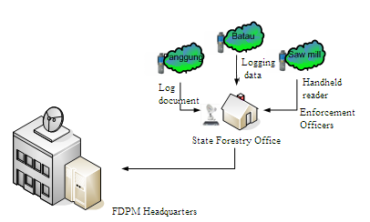

RTRfid System will provide effective timber movement tracking and audit illegal timbers, as well as effectively providing timber and logging information. The system will allow FDPM and logging offices to connect seamlessly using VSAT C-band communication link, allowing applications and data to be shared across all sites (Figure 6). File and Content Delivery services will allow for delivery of information and content to multiple sites at the same time, enabling simultaneous access to the same information across different office locations. Broadband Connectivity will be used to allow two-way delivery of Internet traffic and in providing different bandwidth sizes and usage profiles.

Figure 6: State Forestry Department and Logging Offices to
FDPM Headquarters Communication

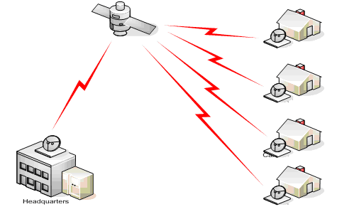
RTRfid System works as a package and can be divided into 3 major components, namely, a Mobile System; a Gateway System; and a Base System. The Mobile System is the data logger that is responsible for collecting identification information about logs. Information gather via the Mobile System will be fed to the Gateway System. The Gateway System acts as a proxy for data transfer and serves to add speed, reliability and security throughout the system. Data captured from the Gateway System is securely transmitted to the Base System that can be considered as a central repository bank to store all log-in real-time information, such as forest revenues collected, alerting security and GPS maps.
1.2 Project Objectives

The project will be conducted in a selected logging licensed peat swamp forest area in the Pekan Forest Reserve, Pahang. The project will contribute significantly in ensuring the detection of non-compliance of timber harvesting procedures and to achieve sustainability of the Ramin timber species that is consistent with the sustainable forest management practices currently being implemented in Peninsular Malaysia. As such, the objectives of the project are as follows:

(i) Development of a customized cost-effective Gonystylus spp. (Ramin) Timber Monitoring (RTRfid) System Using Radio Frequency Identification (RFID) in Peninsular Malaysia.

(ii) Development of an automated detection and notification mechanism for tracing non-compliances using gentry (gate) system in Peninsular Malaysia.

2. Justification

2.1 Problems to be addressed

Illegal logging issues have tarnished Malaysia's image and have affected Malaysia’s market share in some of the global markets that require timber products to be sourced from forests that are legal and sustainably managed. It also costs the government millions of lost forest revenues through non-compliance of forest regulations, such as over-harvesting, harvesting of unspecified tree species, illegal transport of timber, forest tax evasion and the high cost to rehabilitate the degraded forests. In addition, there are also global concerns about the rate at which the Ramin species are being exploited as a result of increasing demand for timber by the industries, both locally and internationally. One of the solutions identified to mitigate the problems is to capture log movement, production and sales by implementing Radio Frequency Identification (RFID) technology that has been used effectively, among others, in airport baggage handling, electronic payment, retail theft prevention, library systems, automotive manufacturing, parking system, as well as in the postal services. The main features that make the RF-based technology such an attractive option include identification without visual contact, read/write capabilities to store and change data, and its ability for cluster reading in order to simultaneously read many tags. In fact, RFID is an acronym that refers to small electronic devices that consist of a small chip and an antenna. The chip typically is capable of carrying 2,000 bytes of data or less. The RFID device serves the same purpose as a bar code or a magnetic strip on the back of a credit card or an ATM card and it provides a unique identifier for that object. Similar to a bar code or magnetic strip which must be scanned to get the information, the RFID device must also be scanned to retrieve the identifying information. However, the advantages of RFID as compared to other scanning devices are RFID requires no line-of-sight requirement, able to read longer range, can stand harsh environment, more storage capability and possesses real-time tracking capability. These features are the principal characteristics which enter the strategic decision taken by the FDPM to implement RFID-based technology and its applications, notably in its forest harvesting operations.

2.2 Intended situation after Project completion

The project is very critical to FDPM in its efforts to modernize its timber tagging system that is currently being used. As there are short-comings in the current tagging system, the electronication of timber identification and monitoring will act as a check-and-balance system to control Ramin harvesting from a logging area in terms of timber species, size, collectable taxes, among others. The project will also enhance the enforcement procedures and activities to be carried out as forest officers will be able to ensure that the Ramin timber harvested are from legal sources and be reported to forest offices of any non-compliances on a real-time basis. This is very crucial to ensure effective forest revenues collection and to boost the morale of forest officers.

2.3 Target beneficiaries

At the end of the project, the results will assist the various Forestry Departments in Peninsular Malaysia and the relevant agencies to address the issue non-compliance of forest harvesting procedures, illegal logging and tax evasion. The results of the project are also important to the FDPM as they form the basis for more knowledge-based decision making, especially in the formulation of cost-effective and efficient forest operation systems based on the principles of sustainable forest management. The results will enable timber exporters to demonstrate to their buyers that the Ramin timber are sourced legally and hopefully they will fetch higher prices in the global market.

2.4 Risks

There will be challenges to the foresters as the usage of this system is still at its infancy in the forestry sector in Peninsular Malaysia. It will challenge the foresters to quickly adapt and operate the system that involve not only information but also communication technology. However, this will not have any significant negative impacts on the success of the project to achieve its objectives.

3.0 Outputs

The expected outputs of the project are:

Objective 1: Development of a customized cost-effective Gonystylus spp. (Ramin) Timber Monitoring (RTRfid) System Using Radio Frequency Identification (RFID) in Peninsular Malaysia.

Output 1.1: To strengthen and improve the efficiency of tree marking operations and forest revenue system, as well as to expedite the issuance of removal passes during the transport of timber from logging areas to mills using a customized cost-effective RFID based timber monitoring system.

Objective 2: evelopment of an automated detection and notification mechanism for tracing non-compliances using gentry (gate) system in Peninsular Malaysia.

Output 2.1: To improve the efficiency of forest enforcement activities and non-compliance detection using customized cost-effective electronic data logger and gentry (gate).

4.0 Activities

Output 1.1: To strengthen and improve the efficiency of tree marking operations and forest revenue system, as well as to expedite the issuance of removal passes during the transport of timber from logging areas to mills using a customized cost-effective RFID based timber monitoring system.

Activity 1.1.1: Documentation and procedures to appoint FDPM’s RFID system consultant.

Activity 1.1.2: Acquisition of computer peripherals, including servers, computers, printers and other related hardware.

Activity 1.1.3: RTRfid system peripherals rental, including, satellite (VSAT) communication system and broadband.

Activity 1.1.4: Issuance of logging licence.

Activity 1.1.5: Inventory work and electronic tree marking in the field.

Activity 1.1.6: Forest harvesting activities.
Output 2.1: To improve the efficiency of forest enforcement activities and non-compliance detection using customized cost-effective electronic data logger and gentry (gate).

Activity 2.1.1 RFID chip acquisition.

Activity 2.1.2 Computer hardware and power cabin and gentry structures rental.

Activity 2.1.3: Forest monitoring and enforcement.

Activity 2.1.4: Report and documentation.

5.0 Work Plan

The project will be carried out over a period of 32 week (8 months) according to the Work Plan as shown in Table 1.

Table 1: Work Plan - The Development of Gonystylus spp. (Ramin) Timber Monitoring System Using Radio Frequency Identification (RFID) in Peninsular Malaysia

Objective/ Output | Activity | Period in months
Objective/ Output | Activity | 1 | 2 | 3 | 4 | 5 | 6 | 7 | 8
Objective 1: | Development of a customized cost-effective Gonystylus spp. (Ramin) Timber Monitoring (RTRfid) System Using Radio Frequency Identification (RFID) in Peninsular Malaysia.
Output 1.1 | To strengthen and improve the efficiency of tree marking operations and forest revenue system, as well as to expedite the issuance of removal passes during the transport of timber from logging areas to mills using a customized cost-effective RFID based timber monitoring system.
 | Activity 1.1.1: Documentation and procedures to appoint FDPM’s system consultant. | X | X | X
 | Activity 1.1.2: Acquisition of computer peripherals, including servers, computers, printer and other related hardware. |  | X | X | X
 | Activity 1.1.3: RTRfid system peripherals rental, including satellite (VSAT) communication system and broadband. |  |  |  | X
 | Activity 1.1.4: Issuance of logging licence. |  |  | X | X
 | Activity 1.1.5: Inventory work and electronic tree marking in the field. |  | X | X | X | X
 | Activity 1.1.6: Forest harvesting activities. |  |  |  |  | X | X | X | X
Objective 2: | Development of an automated detection and notification mechanism for tracing non-compliances using gentry (gate) system in Peninsular Malaysia.
Output 2.1 | To improve the efficiency of forest enforcement activities and non-compliance detection using customized cost-effective electronic data logger and gentry (portal).
 | Activity 2.1.1: RFID chip acquisition. |  |  |  | X | X
 | Activity 2.1.2: Computer hardware and power cabin and gentry structures rental. |  |  |  | X | X | X | X | X
 | Activity 2.1.3: Forest monitoring and enforcement. |  | X | X | X | X | X | X | X
 | Activity 2.1.4: Report and documentation. |  |  |  |  | X | X | X | X

6.0 Budget

6.1 Total Project Budget by Activity

A total of US$ 174,110 is needed to implement the project, of which a sum of US$ 103,200 is required as the contribution from ITTO as shown in Table 2.

Table 2: Detail Project Budget by Activity (US $)

 | ITEM | TOTAL
10. | Project Personnel
 | 11. National Consultants (professional consultant fee) | }
 | 12. Other labour (maintenance of system) | } 32,100
 | 13. Fellowships and Training | }
 | Component Total | 32,100
20. | Sub-contracts
 | Component Total | -
30. | Duty Travel
 | Component Total | -
40. | Capital Items
 | 41. Premises (Power cabin and gentry structure rental) | 15,600
 | 42. Capital equipment (satellite [VSAT] communication system and broadband service and computer hardware) | 33,100
 | 43. Servers and computers | 32,600
 | 44. Printers and other related hardware | 12,500
 | Component Total | 93,800
50. | Consumable Items
 | 51. Raw materials (RFID chip – 15,000 units) | 22,400
 | 52. Office Supplies | 3,100
 | Component Total | 25,500
60. | Miscellaneous
 | Component Total | -
70. | Executing Agency Management Costs
 | Component Total (meeting and final report) | 22,710
 | GRAND TOTAL | 174,110

6.2 Project Budget by Source

The project budget by source is as summarized in Table 3.

Table 3: Project Budget by Source (US $)

Budget  Components | Source
Budget  Components | ITTO | Government of Malaysia (in-kind) | Other Source(s) | Total
10. Project personnel | 32,100 | - | - | 32,100
20. Sub-contracts | - | - | - | -
30. Duty travel | - | - | - | -
40. Capital items | 48,700 | 45,100 | - | 93,800
50. Consumable items | 22,400 | 3,100 | - | 25,500
60. Micellaneous | - | - | - | -
70. Executing Agency Management Costs (15% of Total of Overall Project Budget by Activity) | - | 22,710 | - | 22,710
Total | 103,200 | 70,910 |  | 174,110

PART III: OPERATIONAL ARRANGEMENTS

1.0 Management Structure

The project will be implemented by the Forestry Department Peninsular Malaysia. A Project Technical Working Committee (TWC) will be established to oversee the implementation of the project. The TWC will provide guidance on matters pertaining to the implementation of the project and ensure that the project is directed towards achieving its intended goals. The member of the Committee is shown in Table 4.

Table 4: Members of the Project Technical Working Committee (TWC)

Project Technical Working Committee (TWC) | Members
Forestry Department Peninsular Malaysia | - Director General of Forestry
Forestry Department Peninsular Malaysia | - Deputy Director General of Forestry (Operations)
Forestry Department Peninsular Malaysia | - Director of Management (Project Coordinator/Secretary)
Forestry Department Peninsular Malaysia | - Director of International & Secretariat
Forestry Department Peninsular Malaysia | - Director of Pahang State Forestry Department
Other Institutions | - Consultants

2.0 Monitoring, Reporting and Evaluation

The progress of the project will be monitored through the TWC. Quarterly progress reports will be submitted to the TWC for consideration. The Director of Management as Project Coordinator will be guided by the TWC and will be responsible for the preparation of the reports. Short monthly progress reports based on the achievement of project outputs/activities as described in the Work Plan and a final report will be prepared by the FDPM within two months of project completion for submission to ITTO.

